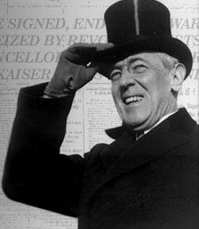  Woodrow Wilson  Fourteen Points  (Five Ideas)  1.  2.  3.  4.  5. | 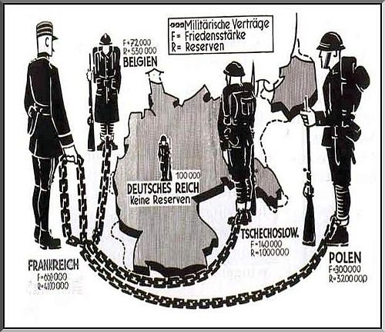  THE TREATY OF VERSAILLES and Germany  1.  2.  3.  4.  5.  6.  7.

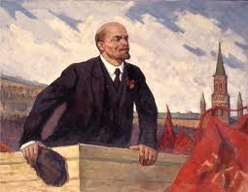
EFFECTS
Russian Revolution

Great Depression
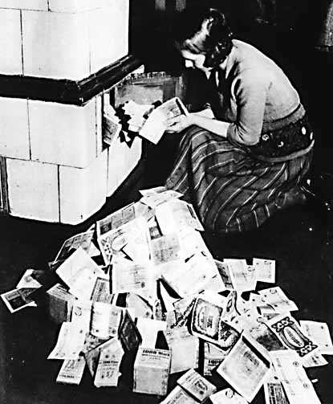

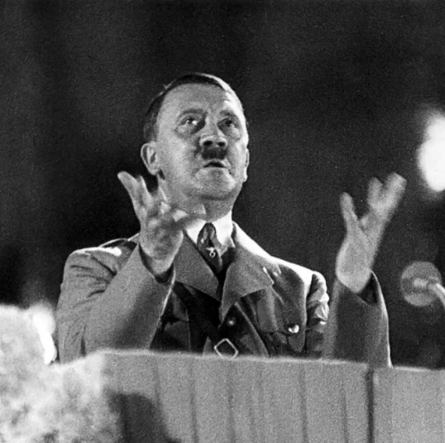
CAUSE
WWI
World War Two
Rise of Dictators

