Vertical and Horizontal Integration

RESOURCES: | 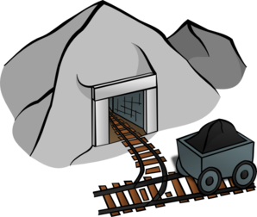
MANUFACTURING: | 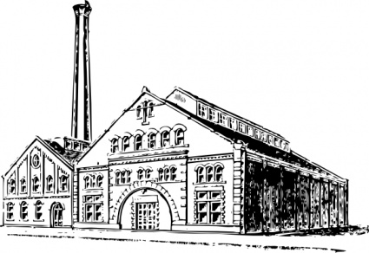
DISTRIBUTION: | 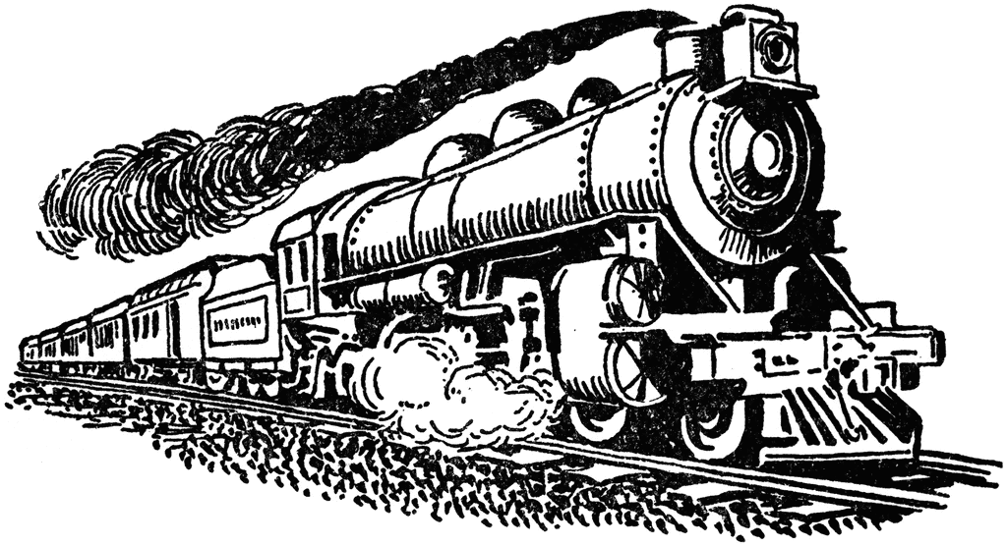

Big Business… … And Labor
(241) What was Andrew Carnegie’s childhood like?  (241) What industry did Carnegie make his fortune in?  (242) What is vertical integration?  (242) What is horizontal integration?  (242) How would Social Darwinism explain the success of the wealthy?  (243) How would it explain the “failure” of the poor?  (243) What industry did John D. Rockefeller make his fortune in?  (243) Why was he called one of the robber barons?  (244) What was the Sherman Antitrust Act, and why did it fail? | (244-245) List some of the problems, dangers, and complaints that workers had to suffer at this time:  (245) How did children workers suffer in particular?  (245) How did workers respond to these issues early on?  (245) How did the American Federation of Labor (AFL) differ from the Knights of Labor?  (245) What is a strike, and how did it help the AFL win some demands?  (246) How did Samuel Gompers differ in his strategy from Eugene V. Debs?  (247) Industry and the government opposed union activity “forcefully,” as the book says. What contributed to a loss of public support for labor?  (249) What event finally pushed public support for better working conditions?

