Social

Moral
Efficiency

Progressivism

Economic

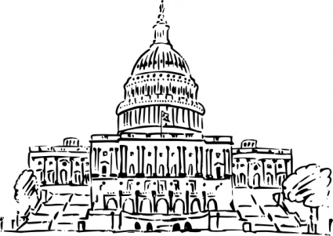  Reforming Government  Initiative  Referendum  Recall  17th Amendment | Women Leading the Way  Cause and Effect  What kinds of job opportunities prompted more women to complete high school?  What social and economic effects did higher education have on women?  Why were women such a large part of the progressive movement?  What were the three parts of the strategy to achieve women suffrage?  1.  2.  3.

