Progressive Presidents
Theodore “Teddy” Roosevelt  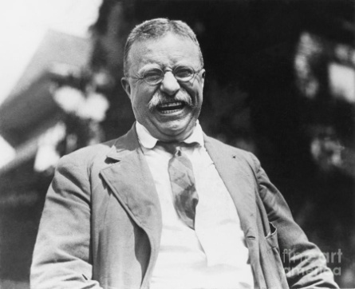  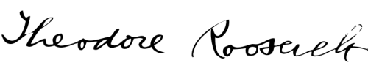  Sherman Antitrust Act (319) How did Roosevelt use the act?  Hepburn Act of 1906 (320) What did this do?  Meat Inspection Act (320) Why was this passed?  Pure Food and Drug Act (322) What did this do?  conservation (323) Why did Roosevelt support it, and what did he do? | 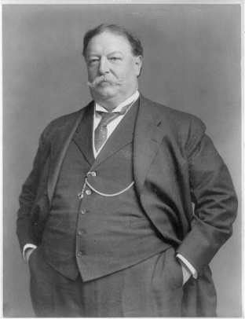  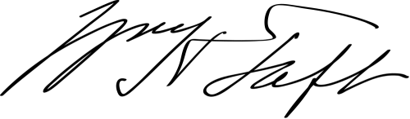  William Howard Taft  How was Taft similar to Roosevelt? (329)  How was Taft different from Roosevelt? (329)  How did Republicans divide? (330)  Bull Moose Party (330) Who’s party was it, and how did it help Woodrow Wilson win in 1912? | 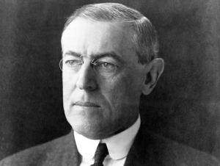  Woodrow Wilson  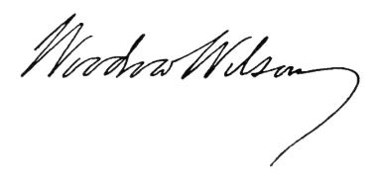  Clayton Antitrust Act (333) What did this do?  Federal Trade Commission (FTC) (333) What was the purpose of this agency?  Sixteenth Amendment (334) How did this change the way Americans were taxed?  Federal Reserve System (334) Why was it needed?  Nineteenth Amendment (335) What did it do?

