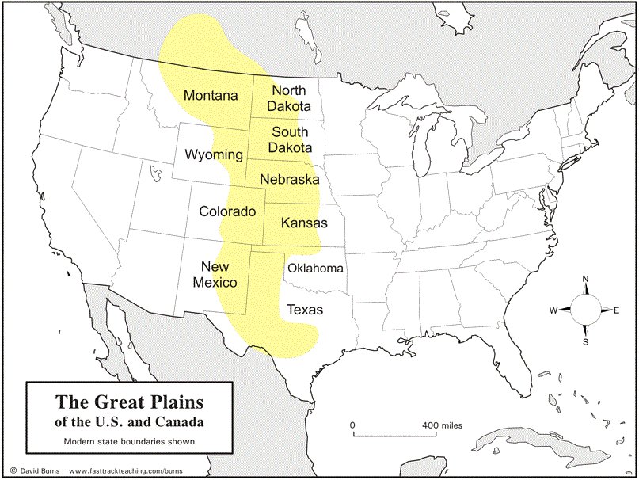
What is manifest destiny (in your own words)?  How did the introduction of horses by the Spanish change the Native American way of life? (203)  Briefly describe the settlers’ view of the land. Why did they believe the Native Americans had “forfeited their rights” to it? (203)  What was one of the earliest “pull factors” for settlers moving west? (204)  Describe the pattern of conflict between Native Americans, settlers, and the U.S. Government leading up the Custer’s defeat at Little Big Horn. (204-6)  What does assimilation mean, and who argued for this strategy? (206)  What did the Dawes Act do? What happened to the rest of the land? (206-7) | What was “perhaps the most significant blow” to the plains Indians’ way of life, and why was this? (207)  What key event led to a boom in demand for cowboys? (209)  What other demand helped drive this demand, and why? (209)  Which city does the text describe as “The Cow Town,” and why? (209)  What factors contributed to the end of the “cattle frontier”? (211)  Of these, which was the most significant factor? (211)  Turn to the map on page 209. On the map on the back of this sheet, mark and label the following cities, as well as drawing the major railroad lines:  San Antonio, Bandera, San Angelo, Fort Worth, Dodge City, Abilene, Kansas City, St. Louis, Pueblo, Denver, Santa Fe, El Paso, Chicago, Cheyenne  Finally, draw the route of the Chisholm Trail.

