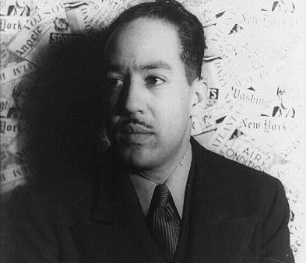
James Langston Hughes was born February 1, 1902, in Joplin, Missouri. His parents divorced when he was a small child, and his father moved to Mexico. He was raised by his grandmother until he was thirteen, when he moved to Lincoln, Illinois, to live with his mother and her husband, before the family eventually settled in Cleveland, Ohio. It was in Lincoln, Illinois, that Hughes began writing poetry. Following graduation, he spent a year in Mexico and a year at Columbia University. During these years, he held odd jobs as an assistant cook, launderer, and a busboy, and travelled to Africa and Europe working as a seaman. In November 1924, he moved to Washington, D.C. Hughes's first book of poetry, The Weary Blues, was published by Alfred A. Knopf in 1926. He finished his college education at Lincoln University in Pennsylvania three years later. In 1930 his first novel, Not Without Laughter, won the Harmon gold medal for literature.
Hughes, who claimed Paul Lawrence Dunbar, Carl Sandburg, and Walt Whitman as his primary influences, is particularly known for his insightful, colorful portrayals of black life in America from the twenties through the sixties. He wrote novels, short stories and plays, as well as poetry, and is also known for his engagement with the world of jazz and the influence it had on his writing, as in "Montage of a Dream Deferred." His life and work were enormously important in shaping the artistic contributions of the Harlem Renaissance of the 1920s. Unlike other notable black poets of the period—Claude McKay, Jean Toomer, and Countee Cullen—Hughes refused to differentiate between his personal experience and the common experience of black America. He wanted to tell the stories of his people in ways that reflected their actual culture, including both their suffering and their love of music, laughter, and language itself.
Langston Hughes died of complications from prostate cancer in May 22, 1967, in New York. In his memory, his residence at 20 East 127th Street in Harlem, New York City, has been given landmark status by the New York City Preservation Commission, and East 127th Street has been renamed "Langston Hughes Place."
Dream Deferred
What happens to a dream deferred?
Does it dry up
Like a raisin in the sun?
Or fester like a sore—
And then run?
Does it stink like rotten meat?
Or crust and sugar over—
like a syrupy sweet?
Maybe it just sags
like a heavy load.
Or does it explode?

Trumpet Player
The Negro
With the trumpet at his lips
Has dark moons of weariness
Beneath his eyes
where the smoldering memory
of slave ships
Blazed to the crack of whips
about thighs
The negro
with the trumpet at his lips
has a head of vibrant hair
tamed down,
patent-leathered now
until it gleams
like jet—
were jet a crown
the music
from the trumpet at his lips
is honey
mixed with liquid fire
the rhythm
from the trumpet at his lips
is ecstasy
distilled from old desire—
Desire
that is longing for the moon
where the moonlight's but a spotlight
in his eyes,
desire
that is longing for the sea
where the sea's a bar-glass
sucker size
The Negro
with the trumpet at his lips
whose jacket
Has a fine one-button roll,
does not know
upon what riff the music slips
It's hypodermic needle
to his soul
but softly
as the tune comes from his throat
trouble
mellows to a golden note

