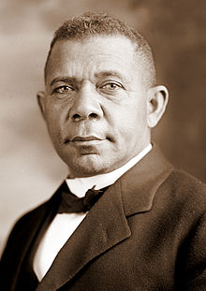
Booker T. Washington

At the dawn of the 20th century, nine out of ten African Americans lived in the South. Jim Crow laws of segregation ruled the land. The Supreme Court upheld the power of the Southern states to create two "separate but equal" societies with its 1896 Plessy v. Ferguson opinion. It would be for a later Supreme Court to judge that they fell short of the "equal" requirement.
Although empowered to vote by the Fifteenth Amendment, poll taxes, literacy tests, and outright violence and intimidation reduced the voting black population to almost zero. Economically, African Americans were primarily poor sharecroppers trapped in an endless cycle of debt. Socially, few whites had come to accept blacks as equals. While progressive reformers ambitiously attacked injustices, it would take great work and great people before change was felt. One man who took up the challenge was Booker T. Washington.

Founding Tuskegee Institute
Born into slavery in 1856, Washington had experienced racism his entire life. When emancipated after the Civil War, he became one of the few African Americans to complete school, whereupon he became a teacher.
Believing in practical education, Washington established a Tuskegee Institute in Alabama at the age of twenty-five. Washington believed that Southern racism was so entrenched that to demand immediate social equality would be unproductive. His school aimed to train African Americans in the skills that would help the most.
Tuskegee Institute became a center for agricultural research. The most famous product of Tuskegee was George Washington Carver. Carver concluded that much more productive use could be made of agricultural lands by diversifying crops. He discovered hundreds of new uses for sweet potatoes, pecans, and peanuts. Peanut butter was one such example. Washington saw a future in this new type of agriculture as a means of raising the economic status of African Americans.

The Atlanta "Compromise"
In 1895, Washington delivered a speech at the Atlanta Exposition. He declared that African Americans should focus on vocational education. Learning Latin and Greek served no purpose in the day-to-day realities of Southern life.
African Americans should abandon their short-term hopes of social and political equality. Washington argued that when whites saw African Americans contributing as productive members of society, equality would naturally follow.
For those dreaming of a black utopia of freedom, Washington declared, "Cast down your bucket where you are." Many whites approved of this moderate stance, while African Americans were split. Critics called his speech the Atlanta Compromise and accused Washington of coddling Southern racism.
Still, by 1900, Washington was seen as the leader of the African American community. In 1901, he published his autobiography, Up from Slavery. He was a self-made man and a role model to thousands. In 1906, he was summoned to the White House by President Theodore Roosevelt. This marked the first time in American history that an African American leader received such a prestigious invitation.
Despite his accomplishments, he was challenged within the black community until his death in 1915. His most outspoken critic was W. E. B. DuBois.
http://www.ushistory.org/us/42d.asp
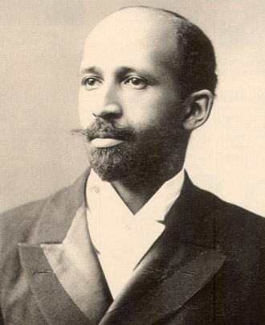
W.E.B. Dubois
William Edward Burghardt DuBois was very angry with Booker T. Washington. Although he admired Washington's intellect and accomplishments, he strongly opposed the position set forth by Washington in his Atlanta Exposition Address. He saw little future in agriculture as the nation rapidly industrialized. DuBois felt that renouncing the goal of complete integration and social equality, even in the short run, was counterproductive and exactly the opposite strategy from what best suited African Americans.

Early Life and Core Beliefs
The childhood of W. E. B. DuBois could not have been more different from that of Booker T. Washington. He was born in Massachusetts in 1868 as a free black. DuBois attended Fisk University and later became the first African American to receive a Ph. D. from Harvard. He secured a teaching job at Atlanta University, where he believed he learned a great deal about the African American experience in the South.
DuBois was a staunch proponent of a classical education and condemned Washington's suggestion that blacks focus only on vocational skills. Without an educated class of leadership, whatever gains were made by blacks could be stripped away by legal loopholes. He believed that every class of people in history had a "talented tenth." The downtrodden masses would rely on their guidance to improve their status in society.
Political and social equality must come first before blacks could hope to have their fair share of the economic pie. He vociferously attacked the Jim Crow laws and practices that inhibited black suffrage. In 1903, he published The Souls of Black Folk, a series of essays assailing Washington's strategy of accommodation.

The Niagra Movement and the NAACP
In 1905, DuBois met with a group of 30 men at Niagara Falls, Canada. They drafted a series of demands essentially calling for an immediate end to all forms of discrimination. The Niagara Movement was denounced as radical by most whites at the time. Educated African Americans, however, supported the resolutions.
Four years later, members of the Niagara Movement formed the National Association for the Advancement of Colored People (NAACP). This organization sought to fight for equality on the national front. It also intended to improve the self-image of African Americans. After centuries of slavery and decades of second-class status, DuBois and others believed that many African Americans had come to accept their position in American society.
DuBois became the editor of the organization's periodical called The Crisis, a job he performed for 20 years. The Crisis contained the expected political essays, but also poems and stories glorifying African American culture and accomplishments. Later, DuBois was invited to attend the organizational meeting for the United Nations in 1946.
As time passed, DuBois began to lose hope that African Americans would ever see full equality in the United States. In 1961, he moved to Ghana. He died at the age of 96 just before Martin Luther King Jr. led the historical civil rights march on Washington.

http://www.ushistory.org/us/42e.asp

