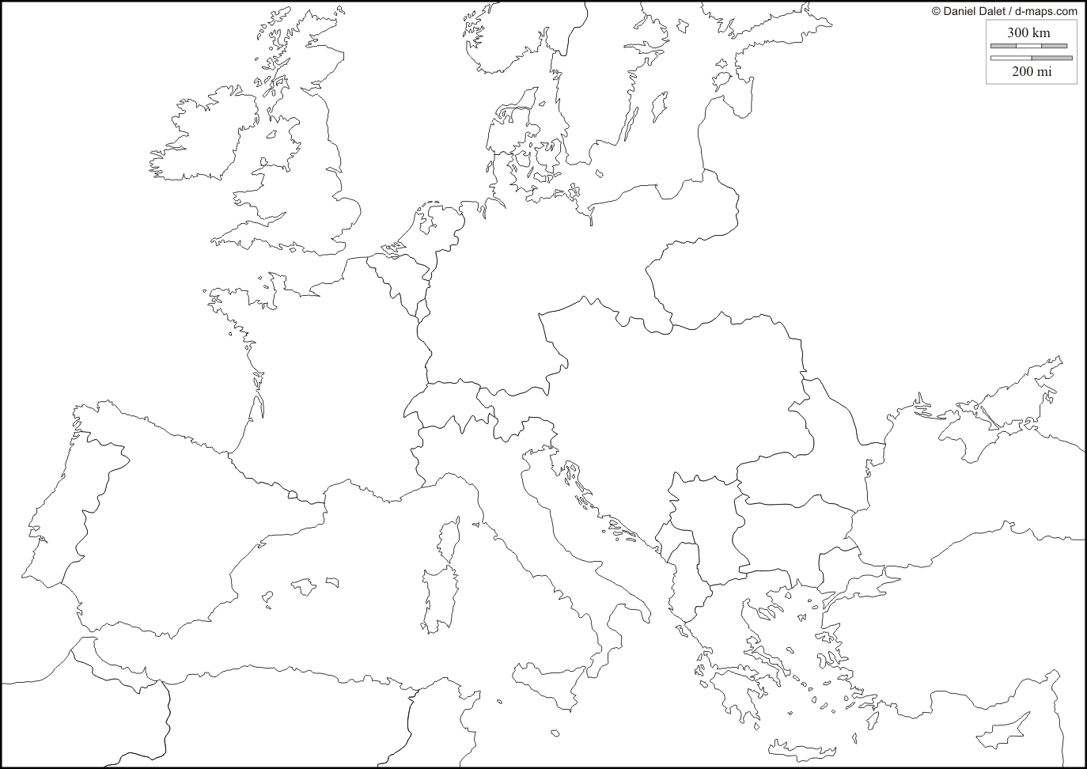
The Great War
INSTRUCTIONS: Use the map on page 375 in your book.
- Label each of the Central Powers: Germany, Austria-Hungary, the Ottoman Empire, Bulgaria
- Choose a color and fill in all the Central Powers with that color.
- Label each of the Allied Powers: Great Britain (including Ireland), France, Belgium, Russia, Italy, Romania, Serbia, Greece, Montenegro, Portugal
- Choose a different color, and fill in all the Allied Powers with that color.
- Label the city of Sarajevo, and draw a small explosion there.
- Copy the “British Blockade” line on the map.
- Copy the “blue lines” on the map around Great Britain and Ireland, and draw a couple submarines there.
- Find the place where the Lusitania was sunk, and draw a small explosion there.
What happened in Sarajevo that set off WWI? (374)

Why did the British blockade anger some Americans? (378)

Why did the sinking of the Lusitania anger many Americans? (378)

What was Wilson’s campaign slogan that helped him get re-elected in 1916? (379)

What three things worked to change Wilson’s mind and bring America into the war? (379)

Who was General John J. Pershing, and what did he believe about the fighting in Europe?

What is a conscientious objector?

Why did Germany ultimately agree to an armistice and stop fighting?

