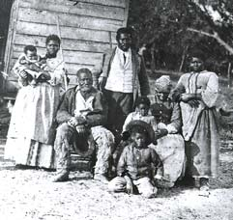
The Meaning of Freedom:

Black and White Responses to the End of Slavery
Confederate defeat and the end of slavery brought far-reaching changes in the lives of all Southerners. The destruction of slavery led inevitably to conflict between blacks seeking to breathe substantive meaning into their freedom by asserting their independence from white control, and whites seeking to retain as much as possible of the old order.
The meaning of freedom itself became a point of conflict in the Reconstruction South. Former slaves relished the opportunity to flaunt their liberation from the innumerable regulations of slavery.
Immediately after the Civil War, they sought to give meaning to freedom by reuniting families separated under slavery, establishing their own churches and schools, seeking economic autonomy, and demanding equal civil and political rights.
Most white Southerners reacted to defeat and emancipation with dismay. Many families had suffered the loss of loved ones and the destruction of property. Some thought of leaving the South altogether, or retreated into nostalgia for the Old South and the Lost Cause of the Confederacy.
In 1865 and 1866 many white Southerners joined memorial associations that established Confederate cemeteries and monuments throughout the region. Others, unwilling to accept a new relationship to former slaves, resorted to violent opposition to the new world being created around them.
Building the Black Community: The Family
Reuniting families separated under slavery, and solidifying existing family relations, were essential to the black definition of freedom. The family stood as the main pillar of the postwar black community.

Most slaves had lived in family units, although they faced the constant threat of separation from loved ones by sale. Freedpeople made remarkable efforts to locate loved ones - a Northern reporter in 1865 encountered a former slave who had walked more than 600 miles searching for his wife and children, from whom he had been sold away during slavery. Slave marriages had no legal standing; now tens of thousands of freedpeople registered their unions before the army, Freedmen's Bureau, and local governments.
Even as an enslaved people, African-Americans maintained strong family ties. After emancipation, African-Americans struggled to reunite families that had been disrupted by sale and many couples legalized their marriages. Family and kinship ties, together with the church, remained the foundation of the black community.
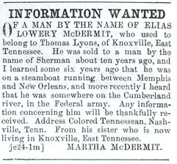
In the early days of freedom, thousands of African-Americans married under the authority of the Freedman's Bureau, an agency established by the federal government to look after the needs of the former slave. Bureau records indicate that some marriages involved young men and women marrying for the first time, while others legalized slave unions made years before.

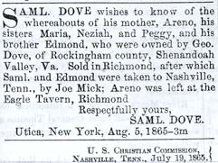
Building the Black Community: The Church
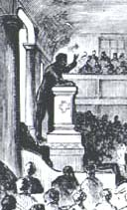
The creation of autonomous black churches was a major achievement of the Reconstruction era, and a central component of blacks' conception of freedom. The first institution fully controlled by African-Americans, the church played a central role in the black community.
Before the Civil War, many rural slaves had held secret religious meetings outside the supervision of their owners. Other slaves, along with free blacks, had belonged to biracial congregations controlled by whites, many of which required black members to sit in the back of the church or the galleries during services.
With emancipation, blacks withdrew from these institutions to create their own churches. They pooled their resources to purchase land and erect church buildings. A place of worship, the church also housed schools, social events, and political gatherings, and sponsored benevolent and fraternal societies. Black ministers also came to play a major role in Reconstruction politics.
Building the Black Community: The School
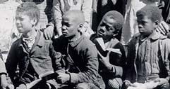
Education, denied them under slavery, was essential to the African-American understanding of freedom. Young and old, the freedpeople flocked to the schools established after the Civil War. For both races, Reconstruction laid the foundation for public schooling in the South.
Northern benevolent societies, the Freedmen's Bureau, and, after 1868, state governments, provided most of the funding for black education, but the initiative often lay with blacks themselves, who purchased land, constructed buildings, and raised money to hire teachers. The desire for learning led families to move to towns and cities so that their children could have access to education, and children to instruct their parents after school hours.
Reconstruction also witnessed the creation of the nation's first black colleges, including Howard University in Washington, D.C., Fisk University in Tennessee and Hampton Institute in Virginia. Initially, these institutions emphasized the training of black teachers and by 1869, blacks outnumbered whites among the nearly 3,000 men and women teaching the freedpeople in the South.
Before the Civil War, only North Carolina among Southern states had established a comprehensive system of education for white children. During Reconstruction, public education came to the South.

http://www.digitalhistory.uh.edu/exhibits/reconstruction/section2/section2_intro.html
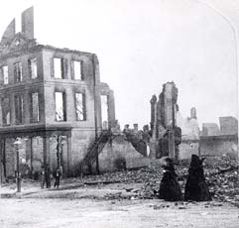
Memory and Mourning
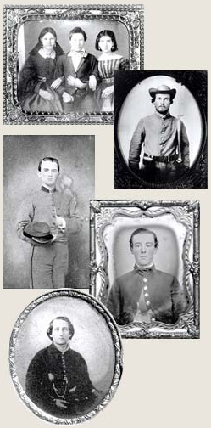
Most Southern whites responded to defeat with grief and dismay. "The demoralization is complete," wrote a Georgia girl. "We are whipped, there is no doubt about it." Privately, white Southerners struggled to come to terms with the appalling loss of life, a disaster without parallel in the American experience.
Many women had taken on new roles during the Civil War, assuming greater and greater authority for managing farms and plantations while their husbands were absent, or serving as nurses, teachers, and in other professions. The death of nearly 260,000 soldiers meant that women would continue to fill these roles, even as they struggled to help surviving husbands and sons adapt to the reality of defeat.
While some white Southerners looked to the future and a New South, others turned with nostalgia to a romanticized view of slavery and of the Confederacy, increasingly remembered as a noble Lost Cause.

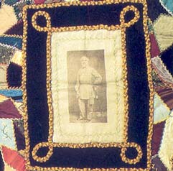
A quilt that features a photograph of Robert E. Lee in the center illustrates how Southerners incorporated images of the Lost Cause into their daily lives. The quilt also contains miniature Confederate flags and memorial ribbons.

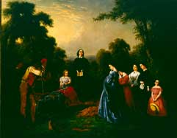
"The Burial of Latanè," was the most popular image of The Lost Cause. Originally a painting by William D. Washington, the harmonious scene depicts a group of valiant Southern women and loyal slaves burying William D. Latanè, a young Confederate hero, in a plantation cemetery far from home.

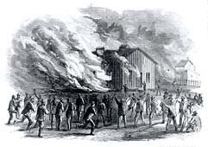
Violence
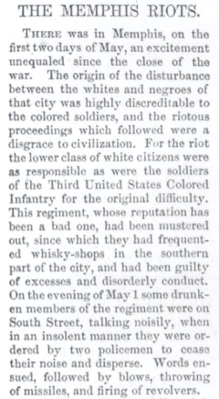
Violence swept across parts of the South in the aftermath of the Civil War, reflecting the immense tensions created by the end of slavery and Confederate defeat, and white Southerners' determined resistance to blacks' quest for autonomy. Freedpeople were assaulted and murdered for attempting to leave plantations, disputing contract settlements, seeking to enter white-controlled churches, and refusing to step off sidewalks to allow white pedestrians to pass.
Occasionally, as in the Memphis and New Orleans riots of 1866, black communities became the victims of wholesale assault by white mobs, aided by the local police. In these outbreaks, schools, churches, and other community institutions, symbols of black freedom, became the targets of violence, as well as private homes and individual African-Americans.
During three days of racial violence in Memphis in May, 1866, white mobs destroyed hundreds of structures in the black community, including a freedman's school.
At least forty-six blacks (most of them Union veterans) died and more than 70 were wounded. Five black women were raped, and 12 churches and 4 schools were burned. Two whites also died in the disturbance.

The Ending of Reconstruction
In the 1870's, violent opposition in the South and the North's retreat from its commitment to equality, resulted in the end of Reconstruction. By 1876, the nation was prepared to abandon its commitment to equality for all citizens regardless of race.
As soon as blacks gained the right to vote, secret societies sprang up in the South, devoted to restoring white supremacy in politics and social life. Most notorious was the Ku Klux Klan, an organization of violent criminals that established a reign of terror in some parts of the South, assaulting and murdering local Republican leaders.
In 1871 and 1872, federal marshals, assisted by U. S. troops, brought to trial scores of Klansmen, crushing the organization. But the North's commitment to Reconstruction soon waned. Many Republicans came to believe that the South should solve its own problems without further interference from Washington. Reports of Reconstruction corruption led many Northerners to conclude that black suffrage had been a mistake. When anti-Reconstruction violence erupted again in Mississippi and South Carolina, the Grant administration refused to intervene.
The election of 1876 hinged on disputed returns from Florida, Louisiana, and South Carolina, where Republican governments still survived. After intense negotiations involving leaders of both parties, the Republican candidate, Rutherford B. Hayes, became president, while Democrats assumed control of the disputed Southern states. Reconstruction had come to an end.

http://www.digitalhistory.uh.edu/exhibits/reconstruction/section2/section2_intro.html

