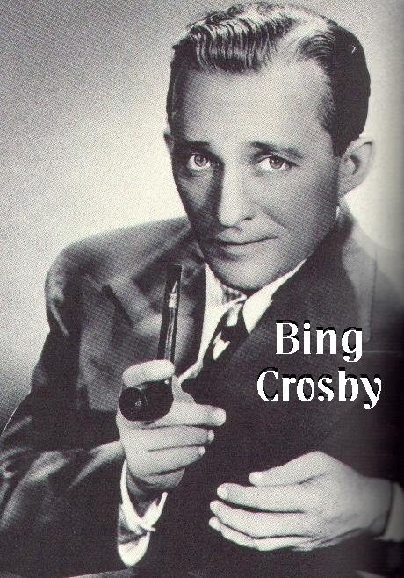
Brother, Can You Spare a Dime?
– As sung by Bing Crosby

They used to tell me I was building a dream
And so I followed the mob
When there was earth to plow or guns to bear
I was always there, right on the job
They used to tell me I was building a dream
With peace and glory ahead
Why should I be standing in line
Just waiting for bread?
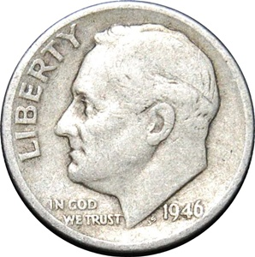
Once I built a railroad, I made it run
Made it race against time
Once I built a railroad, now it's done
Brother, can you spare a dime?
Once I built a tower up to the sun
Brick and rivet and lime
Once I built a tower, now it's done
Brother, can you spare a dime?

Once in khaki suits, gee, we looked swell
Full of that Yankee Doodly Dum
Half a million boots went slogging through Hell
And I was the kid with the drum
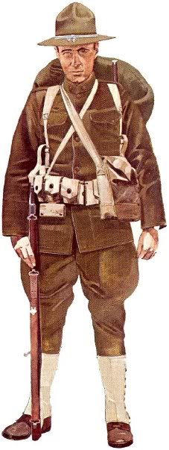
Say, don't you remember? They called me 'Al'
It was 'Al' all the time
Why don't you remember? I'm your pal
Say buddy, can you spare a dime?
Once in khaki suits, ah, gee, we looked swell
Full of that Yankee Doodly Dum
Half a million boots went slogging through Hell
And I was the kid with the drum
Oh, say, don't you remember? They called me 'Al'
It was 'Al' all the time
Say, don't you remember? I'm your pal
Buddy, can you spare a dime?

The Great Depression

- How did the depression affect people in the cities? (472,473)

- How did it affect African Americans and Latinos? (473)

- Why did many farmers lose their land early during the depression? (473)

- What was the Dust Bowl, and how many states were affected? (474)

- What were “hoboes,” and how did they survive? (475)

- What are some ways that women survived in the depression? (475,476)

- How did the depression affect many children? (476)

- What effect did the depression have on people’s attitude toward money and each other? (477)

